Test Case: tc002_SPX_Dev5_Crear_Requisicion_Spot_Con_FAD_Tipo_Cobro_CC
Step 1 - Enter username and password and click to button Enter : Credentials Entered
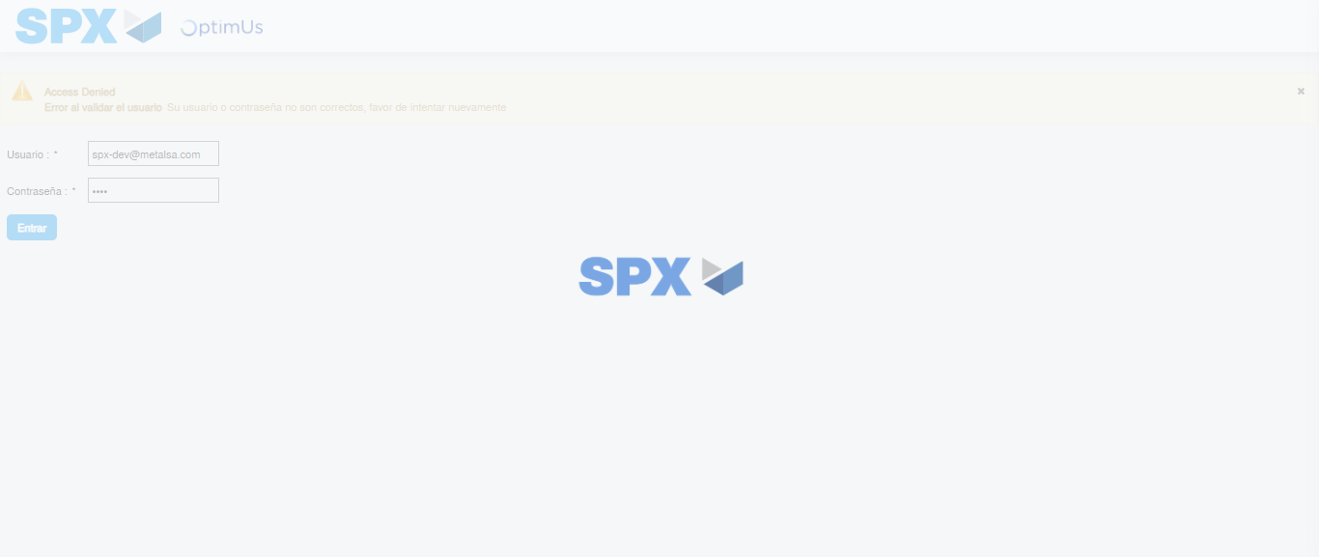Image file-name: QC_Testing-tc002_SPX_Dev5_Crear_Requisicion_Spot_Con_FAD_Tipo_Cobro_CC-1785975964557

Step 2 - Select to UEN and Access to Spot Buy Requisitions : UEN Correctly selected and Correct access
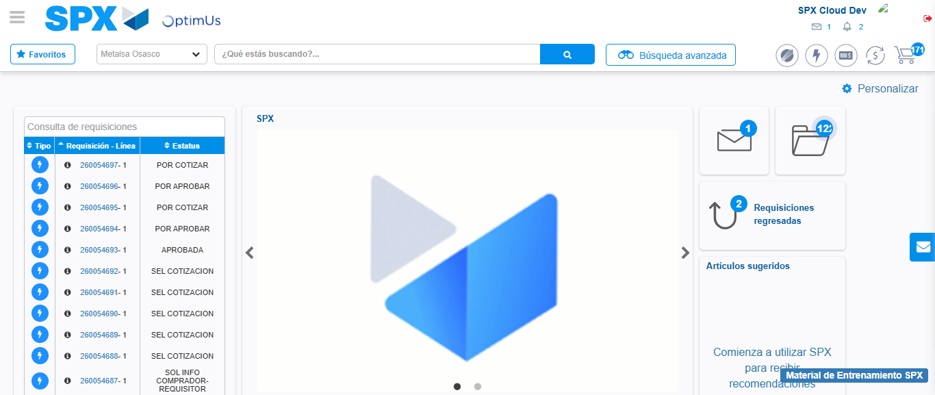Image file-name: QC_Testing-tc002_SPX_Dev5_Crear_Requisicion_Spot_Con_FAD_Tipo_Cobro_CC-1785975989411

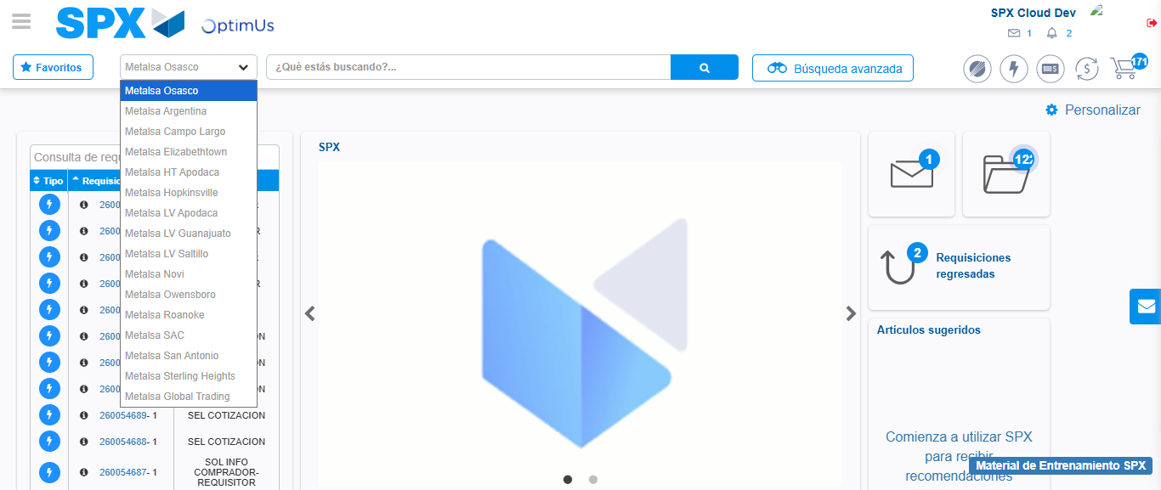Image file-name: QC_Testing-tc002_SPX_Dev5_Crear_Requisicion_Spot_Con_FAD_Tipo_Cobro_CC-1785975992396

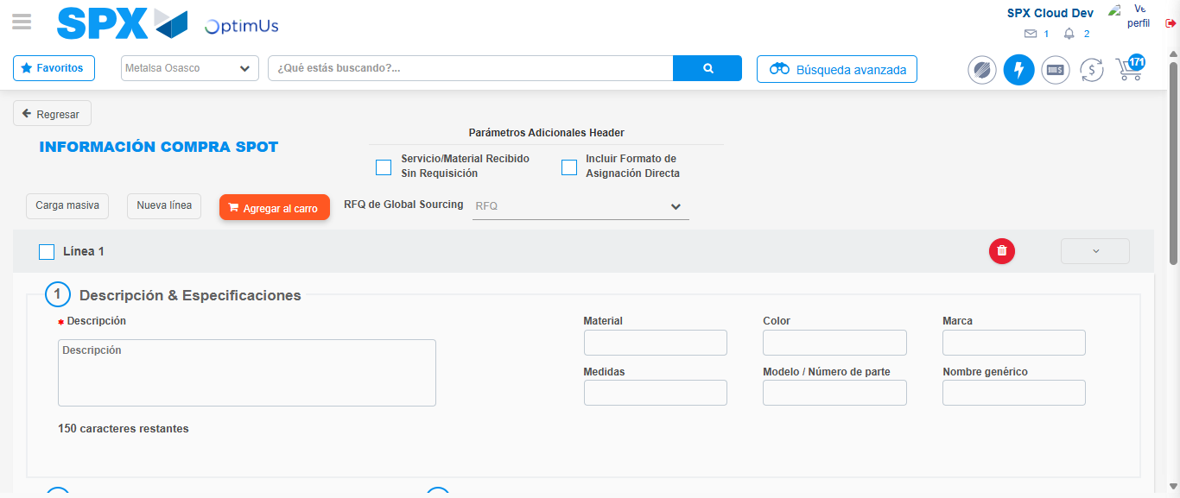Image file-name: QC_Testing-tc002_SPX_Dev5_Crear_Requisicion_Spot_Con_FAD_Tipo_Cobro_CC-1785976001064

Step 3 - Add FAD to Requisition: FAD Successfully Added
Image file-name: QC_Testing-tc002_SPX_Dev5_Crear_Requisicion_Spot_Con_FAD_Tipo_Cobro_CC-1785976001319

Image file-name: QC_Testing-tc002_SPX_Dev5_Crear_Requisicion_Spot_Con_FAD_Tipo_Cobro_CC-1785976001520

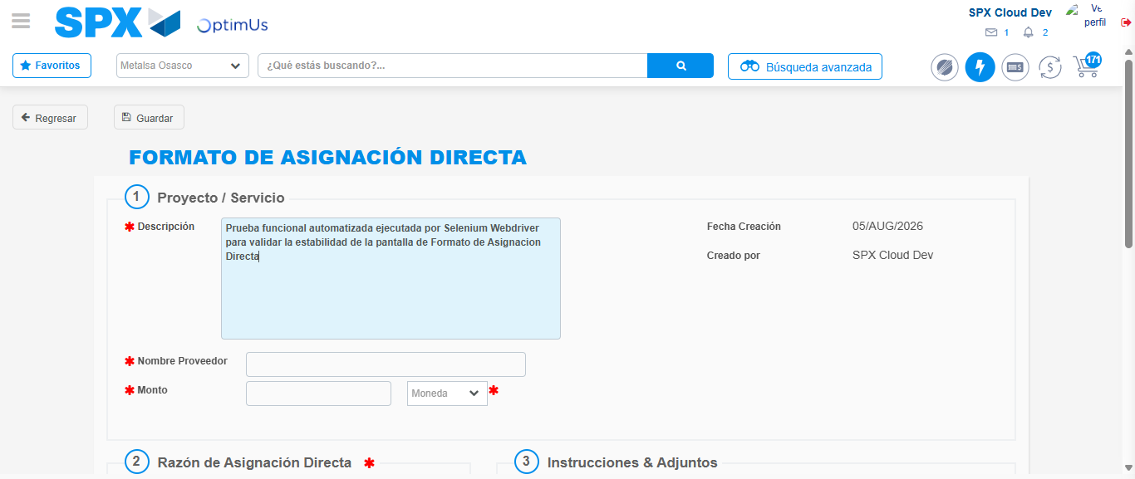Image file-name: QC_Testing-tc002_SPX_Dev5_Crear_Requisicion_Spot_Con_FAD_Tipo_Cobro_CC-1785976004558

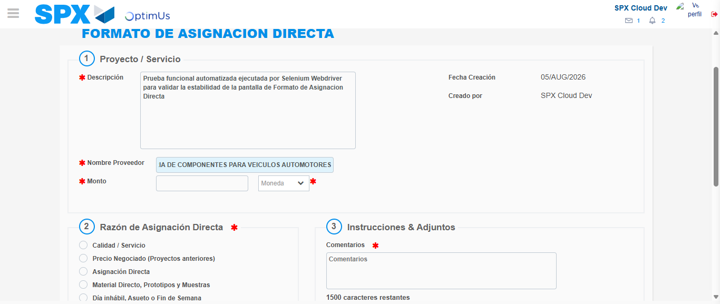Image file-name: QC_Testing-tc002_SPX_Dev5_Crear_Requisicion_Spot_Con_FAD_Tipo_Cobro_CC-1785976015401

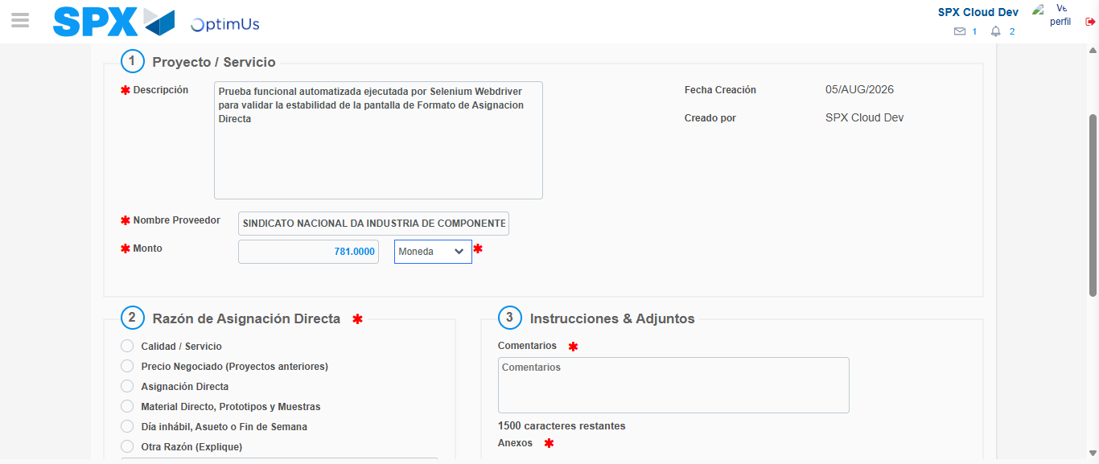Image file-name: QC_Testing-tc002_SPX_Dev5_Crear_Requisicion_Spot_Con_FAD_Tipo_Cobro_CC-1785976015882

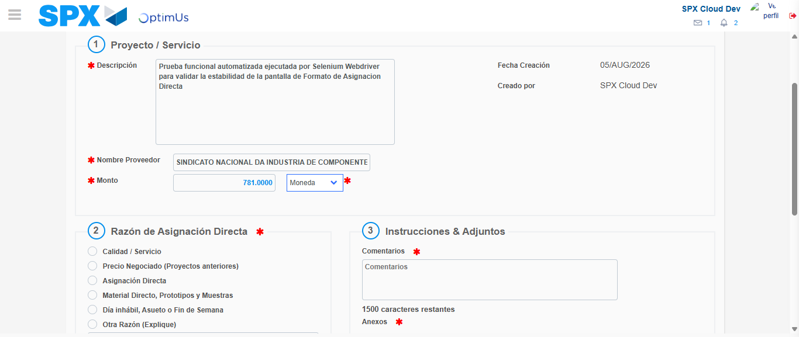Image file-name: QC_Testing-tc002_SPX_Dev5_Crear_Requisicion_Spot_Con_FAD_Tipo_Cobro_CC-1785976016117

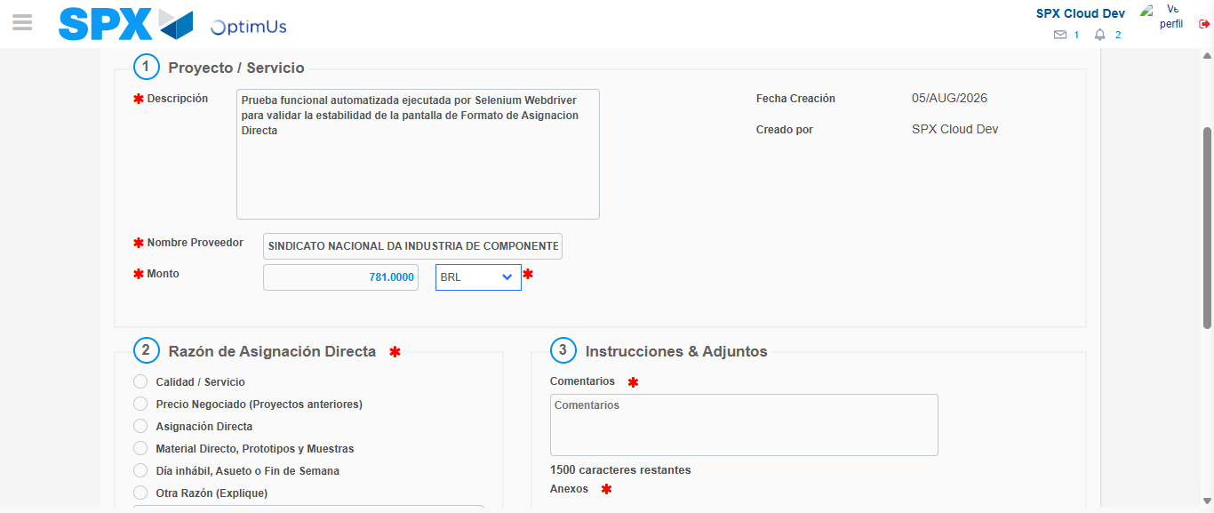Image file-name: QC_Testing-tc002_SPX_Dev5_Crear_Requisicion_Spot_Con_FAD_Tipo_Cobro_CC-1785976016545

Image file-name: QC_Testing-tc002_SPX_Dev5_Crear_Requisicion_Spot_Con_FAD_Tipo_Cobro_CC-1785976016731

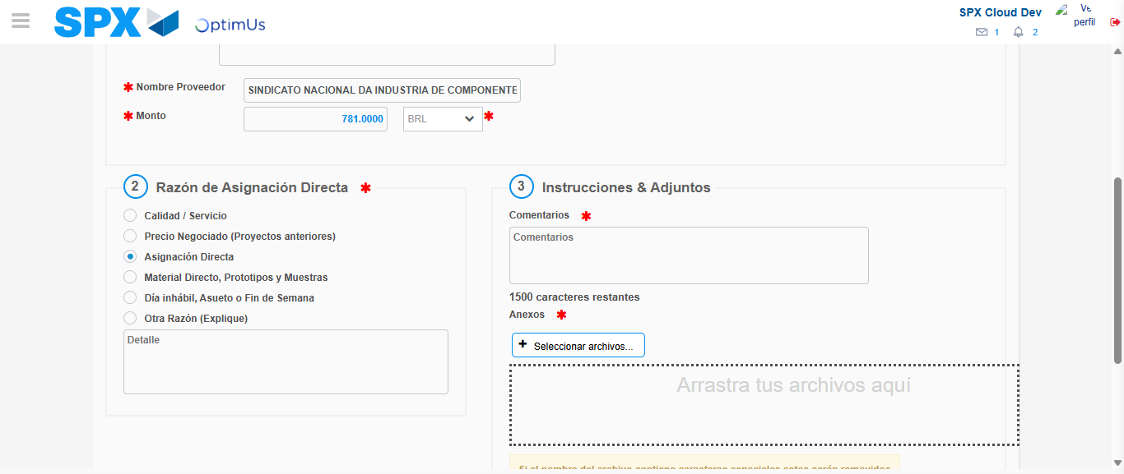Image file-name: QC_Testing-tc002_SPX_Dev5_Crear_Requisicion_Spot_Con_FAD_Tipo_Cobro_CC-1785976017639

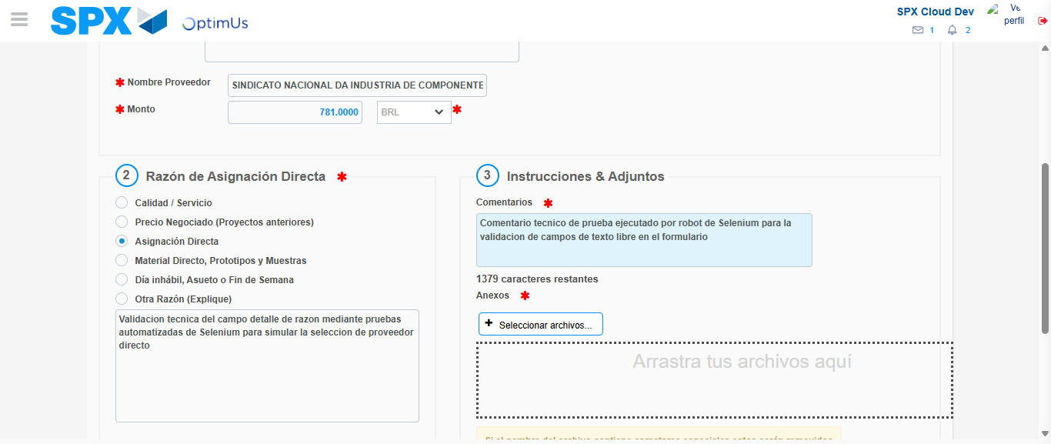Image file-name: QC_Testing-tc002_SPX_Dev5_Crear_Requisicion_Spot_Con_FAD_Tipo_Cobro_CC-1785976029013

Image file-name: QC_Testing-tc002_SPX_Dev5_Crear_Requisicion_Spot_Con_FAD_Tipo_Cobro_CC-1785976029943

Step 4 - Data Capture Spot Buy Requisition: Data captured correctly
Image file-name: QC_Testing-tc002_SPX_Dev5_Crear_Requisicion_Spot_Con_FAD_Tipo_Cobro_CC-1785976001319

Image file-name: QC_Testing-tc002_SPX_Dev5_Crear_Requisicion_Spot_Con_FAD_Tipo_Cobro_CC-1785976001520

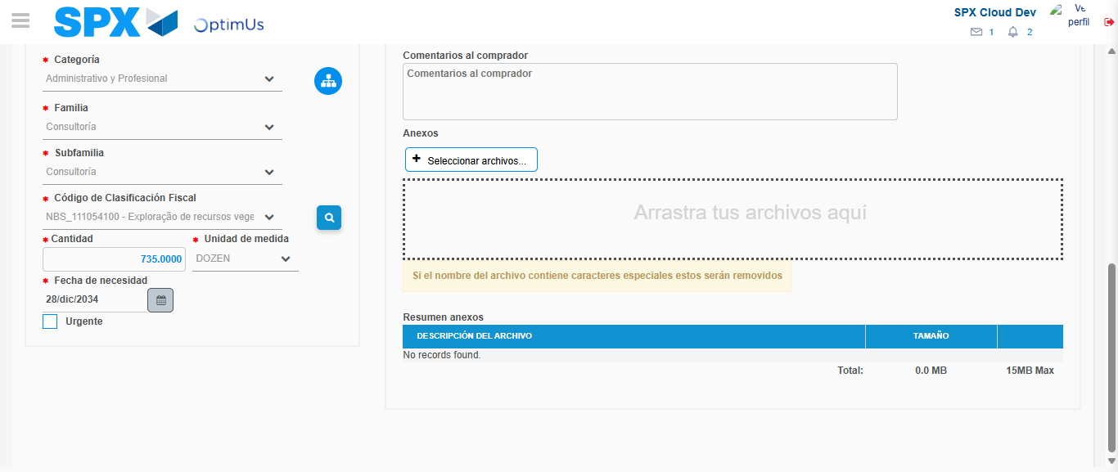Image file-name: QC_Testing-tc002_SPX_Dev5_Crear_Requisicion_Spot_Con_FAD_Tipo_Cobro_CC-1785976049142

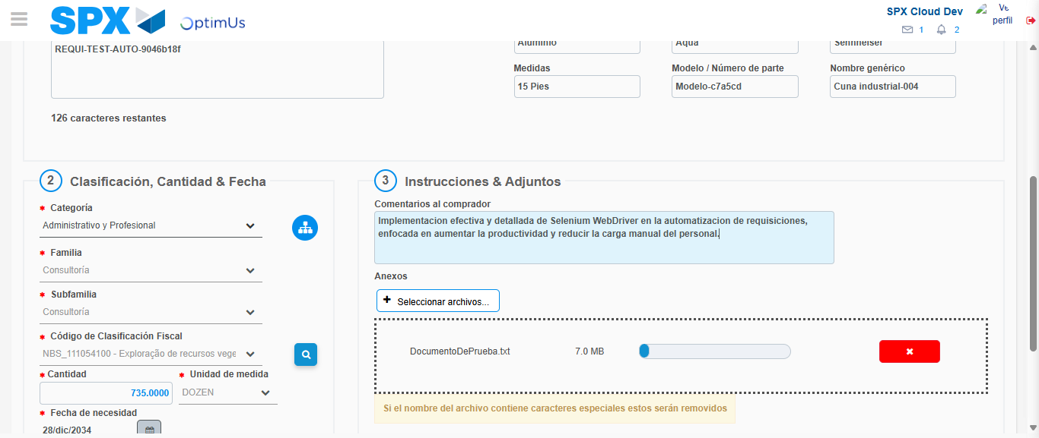Image file-name: QC_Testing-tc002_SPX_Dev5_Crear_Requisicion_Spot_Con_FAD_Tipo_Cobro_CC-1785976050107

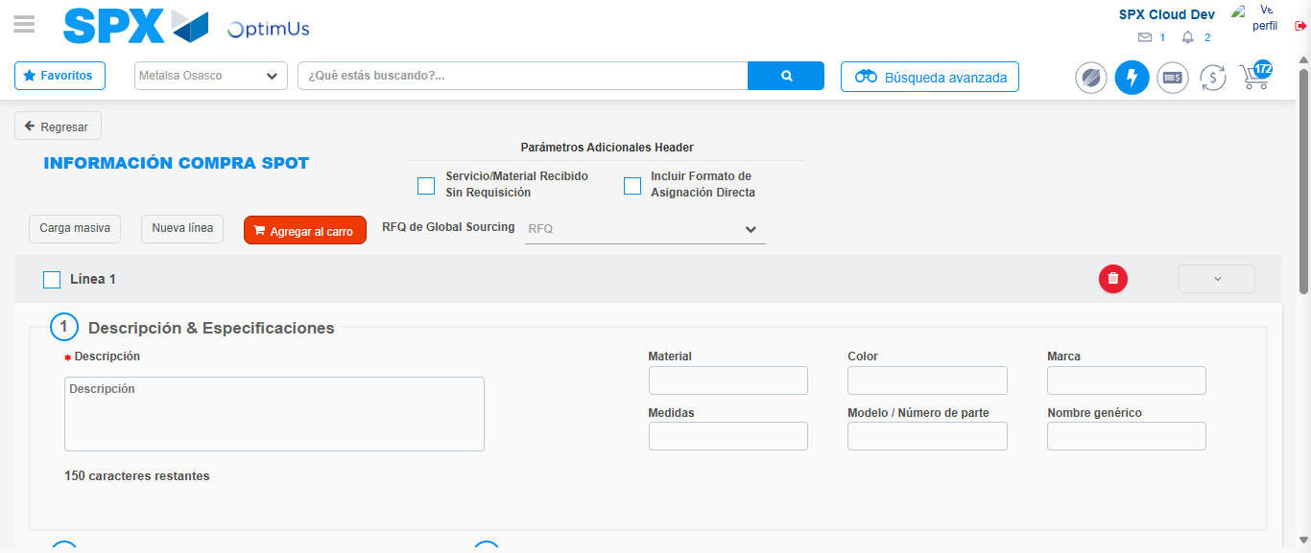Image file-name: QC_Testing-tc002_SPX_Dev5_Crear_Requisicion_Spot_Con_FAD_Tipo_Cobro_CC-1785976060284

Step 8 - Return to Main Page SPX : Return to Main Page SPX
Image file-name: QC_Testing-tc002_SPX_Dev5_Crear_Requisicion_Spot_Con_FAD_Tipo_Cobro_CC-1785975989411

Image file-name: QC_Testing-tc002_SPX_Dev5_Crear_Requisicion_Spot_Con_FAD_Tipo_Cobro_CC-1785975992396

Image file-name: QC_Testing-tc002_SPX_Dev5_Crear_Requisicion_Spot_Con_FAD_Tipo_Cobro_CC-1785976001064

Image file-name: QC_Testing-tc002_SPX_Dev5_Crear_Requisicion_Spot_Con_FAD_Tipo_Cobro_CC-1785976062548

Image file-name: QC_Testing-tc002_SPX_Dev5_Crear_Requisicion_Spot_Con_FAD_Tipo_Cobro_CC-1785976062749

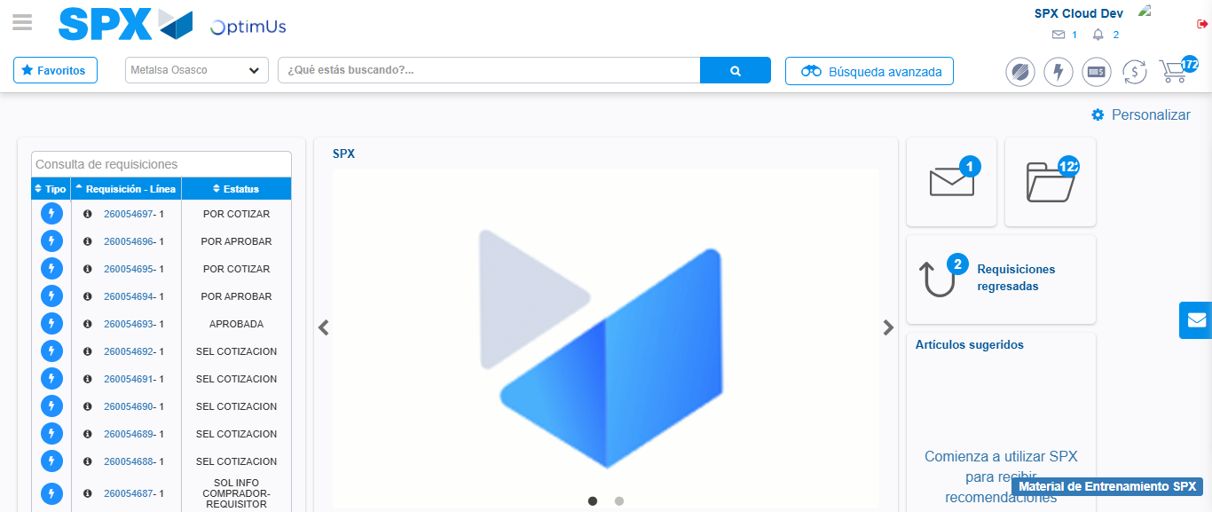Image file-name: QC_Testing-tc002_SPX_Dev5_Crear_Requisicion_Spot_Con_FAD_Tipo_Cobro_CC-1785976083954

Step 9 - Log Out : Log Out SPX
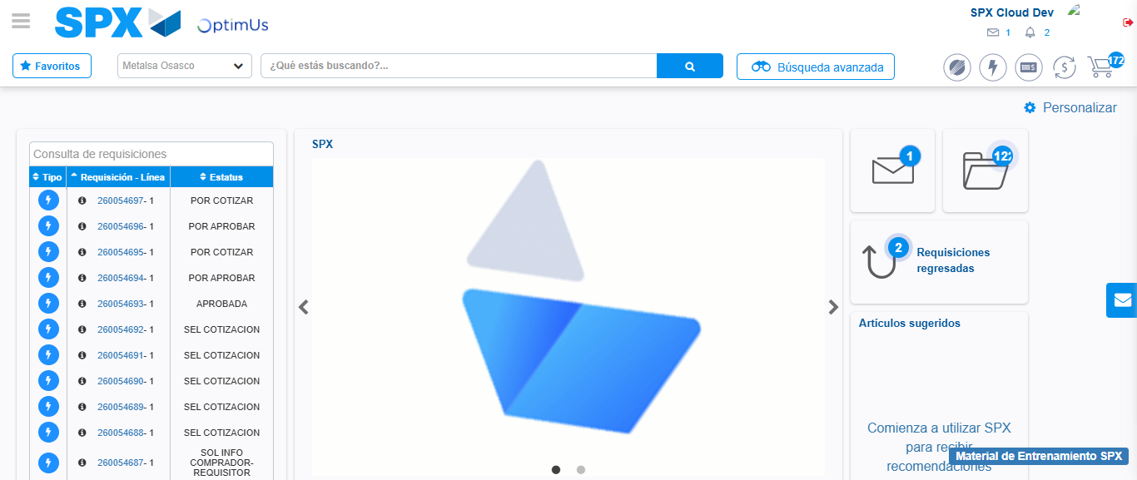Image file-name: QC_Testing-tc002_SPX_Dev5_Crear_Requisicion_Spot_Con_FAD_Tipo_Cobro_CC-1785976084346

